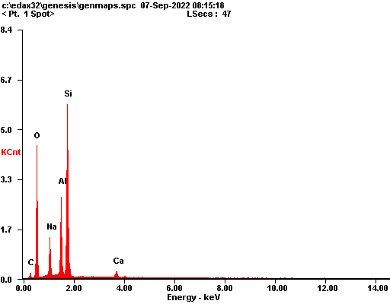

|  |  |  |
| --- | --- | --- |
| ***Element*** | ***Wt%*** | ***At%*** |
| ***CK*** | 05.65 | 09.67 |
| ***OK*** | 36.49 | 46.89 |
| ***NaK*** | 07.71 | 06.89 |
| ***AlK*** | 14.09 | 10.73 |
| ***SiK*** | 33.39 | 24.44 |
| ***CaK*** | 02.68 | 01.38 |
| ***Matrix*** | Correction | ZAF |

